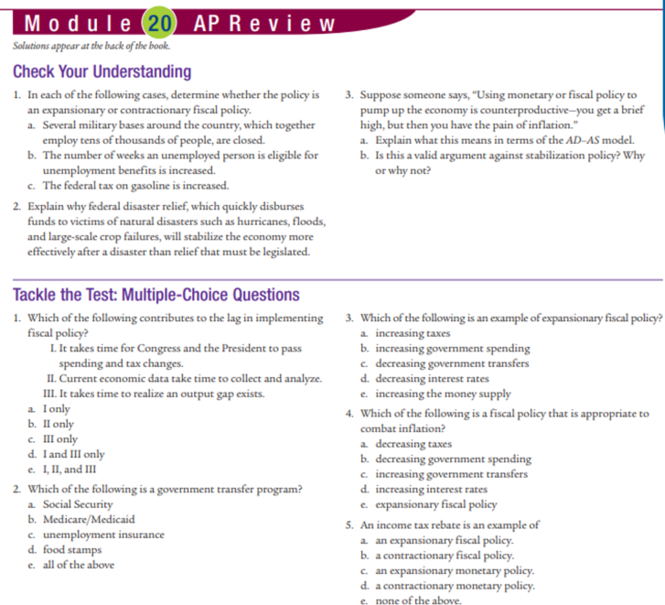
Check your understanding: 1.a. expansionary b. expansionary c. contractionary
2. it is immediate ie. No time lag.
3. a. PL increases and in LR the wages also increase, which decreases SRAS.
4. b. No, not valid. FP or MP can be a valid tool to move AD.
MC: 1.e 2.e 3.b 4.b 5.a
Tackle the test: Free Response. 2.a. draw negative output gap. b. Expansionary
c. Decrease taxes, increase Gov spending, increase gov transfers
